**Reinforcement Learning from Human Feedback (RLHF)**

Imagine teaching a robot to make the perfect cup of coffee. Without guidance, it might endlessly experiment with grind size, water temperature, and brew time, often producing disappointing results. Now, picture a barista tasting each cup and providing feedback: "Too bitter," "Needs more strength," or "Perfect." With this feedback, the robot quickly learns what makes a great cup, efficiently adjusting its process. This scenario captures the essence of **Reinforcement Learning from Human Feedback (RLHF)**—a technique that blends human intuition with machine learning to train AI systems more effectively.

# What is RLHF?

RLHF is a machine learning approach that enhances reinforcement learning by incorporating human judgments into the training loop. Traditional reinforcement learning relies on predefined reward functions to guide an AI agent’s behavior, but many real-world tasks—especially those involving language or complex decision-making or like making coffee to someone’s taste — are difficult to quantify with explicit rewards. RLHF addresses this by using human feedback to create a reward model that reflects nuanced human preferences, enabling AI models to generate outputs that are not only correct but also aligned with human values, safety, and relevance. Let us understand this once again with the help of coffee-making robot analogy.

* **Traditional RL:** The robot tries recipes at random, receiving a numeric score for each cup (e.g., based on bitterness).
* **RLHF:** Instead of just scores, a human barista provides qualitative feedback, shaping the robot’s understanding of what “good” coffee means.

## How Does RLHF Work?

The RLHF training process generally unfolds in three stages:

### 1. Supervised Pretraining

A large neural network, like our robot’s initial coffee-making algorithm, is first trained on a dataset of coffee recipes and outcomes. This gives the robot a foundational understanding of brewing techniques. For example, the robot learns basic recipes and brewing parameters from a cookbook.

### 2. Reward Model Training

Humans evaluate different outputs generated by the model for given prompts, ranking or scoring them based on quality, safety, or alignment with desired behaviors. These human preferences are used to train a separate reward model that predicts how humans would rate new outputs. For example, the barista tastes each cup and says, “Too bitter,” “Too weak,” or “Perfect.” The barista evaluates the robot’s coffee, ranking or scoring each cup based on taste. This feedback is used to train a reward model that predicts how a human would rate new cups. The robot learns to associate certain brewing choices with positive or negative feedback.

### 3. Reinforcement Learning Fine-Tuning

The base model is fine-tuned using reinforcement learning algorithms (commonly Proximal Policy Optimization, PPO) to maximize the reward model’s scores. This iterative process refines the model’s behavior to produce responses that better satisfy human expectations. For example, the robot tweaks grind size or water temperature after each round of feedback, gradually improving its coffee.

# Why is RLHF Important?

In natural language processing (NLP), tasks such as generating helpful, truthful, and contextually appropriate text are challenging to define with explicit rules. Without human guidance, language models might produce irrelevant, biased, or unsafe responses. RLHF enables models like OpenAI’s GPT-4 and Google’s Gemini to generate conversational, natural-sounding, and safe outputs by learning directly from human preferences.

For example, GPT-4, which powers ChatGPT, uses RLHF to move beyond merely predicting the next word. Instead, it learns to understand the intent behind queries and produce coherent, context-aware answers that help users make informed decisions. This human-in-the-loop training differentiates it from traditional chatbots that rely on canned responses.

# RLHF Applications

RLHF’s impact extends beyond chatbots and language models:

* **Education:** Personalized tutoring systems use RLHF to tailor explanations and learning materials to students’ needs, improving engagement and comprehension.
* **Healthcare:** AI models trained with RLHF provide accurate, context-sensitive medical information and assist in summarizing patient records, aligning with expert feedback for safety and reliability.
* **Coding Assistance:** RLHF refines AI-generated code by incorporating developer feedback, helping with debugging and adherence to best practices.
* **Robotics:** Robots learn complex tasks more efficiently by receiving human feedback, reducing trial-and-error failures and improving task success rates.
* **Gaming:** RLHF has been employed to train AI agents that outperform humans in complex games like Dota 2 and StarCraft, where human feedback helps guide strategic decision-making.

## Technical Deep Dive: Simple RLHF Code Example

Below is a Python code snippet that simulates a coffee-making robot adjusting its coffee strength based on human (barista) feedback. This illustrates the RLHF loop in a tangible way:

**import** random

*# Simulated coffee strength levels (1 to 10)*

coffee_strength = 5

*# Human feedback function*

*# Returns +1 if coffee is "perfect" (strength 7), -1 if too weak (<7), -1 if too strong (>7)*

**def** human_feedback(strength):

**if** strength == 7:

**return** 1

**elif** strength < 7:

**return** -1

**else**:

**return** -1

*# Reinforcement learning loop*

**for** episode **in** range(10):

feedback = human_feedback(coffee_strength)

**print**(f"Episode {episode+1}: Coffee strength = {coffee_strength}, Human feedback = {feedback}")

*# Adjust coffee strength based on feedback*

coffee_strength += feedback

*# Keep strength within bounds*

coffee_strength = max(1, min(10, coffee_strength))

**print**(f"Final coffee strength: {coffee_strength}")

This code demonstrates how the robot iteratively improves its coffee by incorporating human feedback—mirroring the RLHF process.

## Visualizing the RLHF Process

The following flowchart illustrates the RLHF process using the coffee-making robot example. It highlights the iterative cycle of making coffee, receiving feedback, and adjusting parameters:

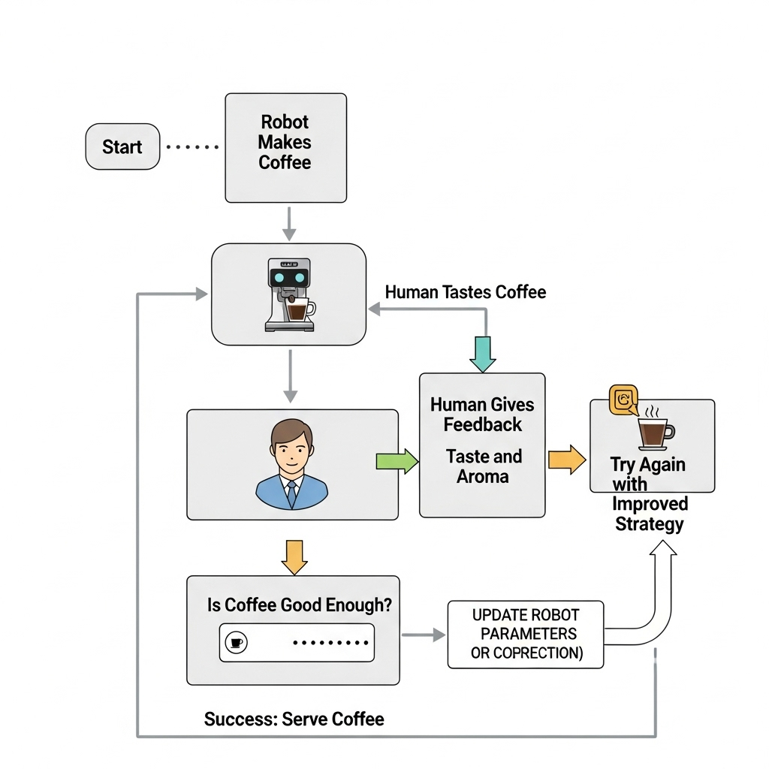

Figure Flowchart of RLHF process illustrated with the coffee-making robot example

# Challenges in RLHF

Despite its advantages, RLHF faces several challenges:

* **Data Collection:** Gathering high-quality human feedback is costly and time-intensive, limiting scalability.
* **Reward Model Reliability:** Designing reward models that accurately reflect diverse human values without being exploited by the AI is difficult.
* **Bias and Safety:** Human feedback can inadvertently introduce biases, and models may still produce undesirable outputs if not carefully monitored.
* **Generalization:** Reward models trained on specific feedback may struggle to generalize to new or unexpected scenarios.

In summary, Reinforcement Learning from Human Feedback transforms AI training by integrating human insight directly into the learning process. Like the coffee-making robot guided by a skilled barista, RLHF steers AI models toward producing outputs that are not only accurate but also meaningful and aligned with human values—paving the way for more trustworthy and effective artificial intelligence.

## Assessment

## ****A. Multiple Choice Questions****

**1. What is the primary purpose of using human feedback in Reinforcement Learning from Human Feedback (RLHF)?**  
a) To replace the need for any reward function  
b) To create a reward model that reflects human preferences  
c) To automate data collection without human involvement  
d) To speed up supervised pretraining

**Answer:** b) To create a reward model that reflects human preferences

**2. Which reinforcement learning algorithm is commonly used during the fine-tuning stage in RLHF?**  
a) Q-Learning  
b) Deep Q-Network (DQN)  
c) Proximal Policy Optimization (PPO)  
d) Monte Carlo Tree Search (MCTS)

**Answer:** c) Proximal Policy Optimization (PPO)

**3. In the coffee-making robot analogy, what does the human barista’s feedback represent in the RLHF process?**  
a) The initial supervised training data  
b) The reward signal used to train the reward model  
c) The final output of the AI system  
d) The exploration strategy of the robot

**Answer:** b) The reward signal used to train the reward model

## ****B. Find the output:****

**Given the following simplified Python function representing human feedback in the coffee-making robot example, what output will the function return if the coffee strength is 5?**

def human_feedback(strength):

if strength == 7:

return 1

elif strength < 7:

return -1

else:

return -1

**Answer: -1 (because 5 < 7, so the function returns -1 indicating the coffee is too weak)**